

DELPHIC

Game Design Document



- Mohammad Waqas Wani (2021702018)

- Shivansh Bhasin (2019112006)

- T.Srikanth (2019900090)

# Title Page

## Game Name

Delphic

# Game Overview

## Game Concept

It is a puzzle/adventure game where the player travels through the different parts of earth and searches for the hidden Staff of Zeus, the ruler of the skies which was left untouched for thousands of millennia by using clues as texts which are provided by GPT2 (deep learning text- generation model).

## Genre

Puzzle and Adventure **2.3.Target Audience** Every abled person.

## Game Flow Summary

In this game there are different levels with different objects and themes. The mission of the player is to search for clues hidden in the different objects. Based on the clues the player has to pinpoint the location of the next clue on the next object in a sequential order and complete interacting with all objects to go to the next level. At the end of the final level the Staff of Zeus is obtained by the player as a reward.

## Look and Feel

It is a single player, 2D platformer game with different themes, backgrounds and interactable objects. There are sound effects for different choices that the player makes. Each level/sublevel will have its own themes.

# Gameplay and Mechanics

## Gameplay

* + 1. **Game Progression:**

The game is a linear game with levels where the player can move in both directions. As the player completes level 1, the player moves to level 2 and so on. The overall difficulty of the levels as well the sequential clues in each level increase as the level/game progresses, with level 3 being the hardest.

## Mission/challenge Structure:

The player has to guess the location of the next object and interact with it with the help of the clue obtained on the previous object in a sequential order. To know what the passphrase is, the player has to interact with the objects, gather clues and arrive at the required passphrase.

The game provides the player with a limited NLP super power, which when used, will enable the player to gather clues that are provided by an expanded text (a paragraph or a sequence of sentences inferenced from a GPT2 deep learning model). So, the ideal run would be fast (takes the least time) and also by using the NLP superpower the least number of times.

## Puzzle Structure:

The clues on each level are hidden inside and around the objects like the snake pit, volcano, near a poisonous flower, near the feet of an angle, bottom of the steps of a palace etc.Initially the player will be given a starting clue that enables them to go to the first specific object to look for the next clue and it would then sequentially follow.

If at any time the player dies they are rest back to the start of this level. This resets every time a player progresses to the next level.

## Objectives

The central objective of the game is to get the Staff of Zeus by sequentially completing the level and thereafter reach the final level of the game.

## Play Flow

The game flows from level to level. At any level, the player has to extract the passphrase using the sequential clues. The player can use the NLP superpower. Also, the number of times the NLP superpower is used is limited for each level.

The fun part of the game comes from guessing the passphrase from the clues to move to the next level.

Each level/sublevel is rendered in different spaces, themes and objects like hell, underground and the sky.

# Mechanics

## Physics

It is an exploratory game with 2D space where gravity is present, and the player has to jump on certain objects to reach certain other objects which are placed at varying elevations. The space is limited by walls on both sides. The NLP power would be a diamond shaped structure resting on one of the objects or a platform. It can be collected by going near it and interacting with it.

## Movement in the game

AD for left/right movement, Space to jump diagonal jumping, E to interact with objects when within a certain radius.

## Objects

Trees, Clouds, Mountains, Buildings, Gates, Spikes, Mythical characters, Rivers, Staff of Zeus, Thrones, NLP superpower aka diamond tool, sea hydra etc.

## Actions

E for interacting with objects, AD for movement, SPACE for jump.

## Combat

None except for basic dodging on some levels.

## Economy

If the player is able to cross all levels without any NLP superpower, then maximum points would be awarded.

The health points are reduced when:

1. the NLP superpower is used, and
2. when the player breaks the sequence of the clues to unlock.

## ScreenFlow

At the start, a menu with following options is shown:

1. Begin a new game,
2. Instructions on how to play the game,
3. Quit.

The first option is used to start a new game. When a new game is clicked another menu appears. There we can select the level we want to play. From there we can start our game by clicking on play. When a level is started, the player is sent to the world where the level begins, and the player can start moving and searching for clues. For the first few seconds of the level, the player is shown the initial clue that would lead the player to the subsequent clue. Once the player completes a level (enters the correct passphrase), an acknowledgement is displayed for completing the level. On pressing *{esc} key*, the player can pause the game, and choose to quit the game, or resume.

# Game Options

There are different game options inside the game with three outer levels. Another important option is the ability to choose the NLP superpower, if the player feels stuck at any level or sublevel.

# Replaying and Saving

When the player returns to the menu after the game is over, or through the pause menu, the player's progress is saved. One can choose to resume from the last saved state, or to start from the beginning under the play-menu. Levels can be paused using the *{esc}* key.

# Cheats and Easter Eggs

In certain sublevels, certain hints, references and easter eggs related to these levels can be found along with the wall jump exploit.

# Story, Setting and Character

## Story and Narrative

Our MC’s damned soul was roaming around in the nether when suddenly a light flashes and he sees himself hovering over his family burning in the eternal red fire. And with no recollection of his life whatsoever, MC is then teleported to a big tree, which glows white hot and is surrounded by a luminous green fire. In this dream world he starts to walk down the burning branches scorching his feet. The tree glows much brighter as MC walks closer to the orb in the middle with his face burning. “Why am I here?” he shouts and then grabs the white thing in the middle as his spiritual body is almost turned to ash. He then sees another blinding light and a seelie is revealed right next to his arm. “I

have many faces, the one you seek lies in the arms of gods in Olympus”. Come find me and all the questions you are pained with will be answered by the holy staff.

Our MC’s soul is then manifested in the deepest pit of hell where he takes the body of a warrior and with scars all over his body sets out to find the Staff in the heavenly city of Olympus.

The scope of this game ends when the MC finds the Staff of Zeus which helps him to witness the actual events that happened that fateful night. He also finds out that he was controlled by an unknown god, who made him kill himself and his family - as he possessed an amulet of dark power granted to him by the wife of Zeus, Hera which the unknown god wanted for himself.

The scope can be increased by building a sequel to the game (for e.g., Delphic 2). In this sequel, what MC does with the Staff - like avenging his family and slaying the unknown god who killed his family and thereafter, resurrecting his family.

## Game World

* + 1. **General look and feel of world**

Whole world comprises several levels and is adjourned with beautiful backgrounds where every level has assorted phenomenon which make up the level. There are multiple levels comprising mythical characters, some of which interact with the player. There are gates at the end of each level in order to move to the next one by entering the passphrase.

## Area

Each level has its unique objects which can be interacted with and its own 2D space. There is a gate at the end of each level which leads to the next level.

## Characters

There is an avatar of the player, and there are other mythical characters such as the three-headed dog Cerberus, the sphinx. The look of the avatar is akin to a mage warrior of young age. The avatar does not possess any special abilities other than the one provided by the NLP superpowers. The three headed dog Cerberus is a demon of hell capable of killing and eating the player. The Sea hydra has the ability to kill the player if her riddles are not answered correctly.

# Levels

There are 3 levels in our game. Each one of these levels can have one or more sublevels with unique themes and scenes.

### Level 0: Hell

Our story starts from the bottommost pit of hell where our MC’s soul is given new life to seek answers and to find the staff of Zeus. This level has a hell-themed background with objects and has the sublevel Hades’ palace where clues are hidden. He travels through hell and crosses the toxic river Styx. The three-headed dog Cerberus will be guarding the gates of hell and then our MC has to dodge him and enter the passphrase at the gate to enter the Black Caves. The MC will find clues and reach the end of the palace to where Cerberus guards the gates of hell.

### Level 1: The Black Caves

This level consists of dangerous ravines and falling stalactites. Our MC crosses these mines and finds hidden clues and uses the passphrase to unlock the portal to enter the stairway to olmypus.

### Level 3: Olympus

Our character when entering the abode of gods traverses through the labyrinth of Olympus. The MC encounters the sea hydra who guards the staff. The player has three chances to give the correct passphrase, which when given. Solving the final clue results in finding the staff which is buried deep under the sea inside the sea-hydra which can be frozen to solid stone.

# Interface

## Visual System

The camera view is facing the player in the generic 2D platformer fashion, sufficiently distanced for a complete view. The menus include the main menu, the pause menu.

## Control System

AD for movement, SPACE to jump, E to interact with objects

*{esc}* to pause the game, bringing up the pause menu.

## Audio, music, sound effects

Final Interactions with objects have a particular sound.

Dying to different objects have sounds.

## Help System

If a player is stuck in a level and can’t figure out how to get out, they can use the NLP superpower to get a text and then figure out the next clue/passphrase from that.

# Artificial Intelligence

## Opponent and Enemy AI

The timing matters to dodge the enemy and can be strategized since the motion is static in boundary sense.

## Non-combat and Friendly Characters

The character of the sphinx does not attack the player and is just a simple interaction and the sea-hydra is frozen solid in stone when disabled

## Support AI

Collision Detection.

Collision detection is used when a player collides with enemies, traps, walls and objects.

NLP interactions with GPT2 deep learning model.

Interaction detection.

# Technical

## Target Hardware

Windows/Linux PCs with minimum reasonable ram and storage, and preferably a dedicated GPU.

## Development hardware and software

Game Development - Unity Text generation model - GPT2 Python and relevant packages

## Network requirements

Basic. (Please don’t use IIIT network as gpt2 port is blocked)

# Game Art

# 

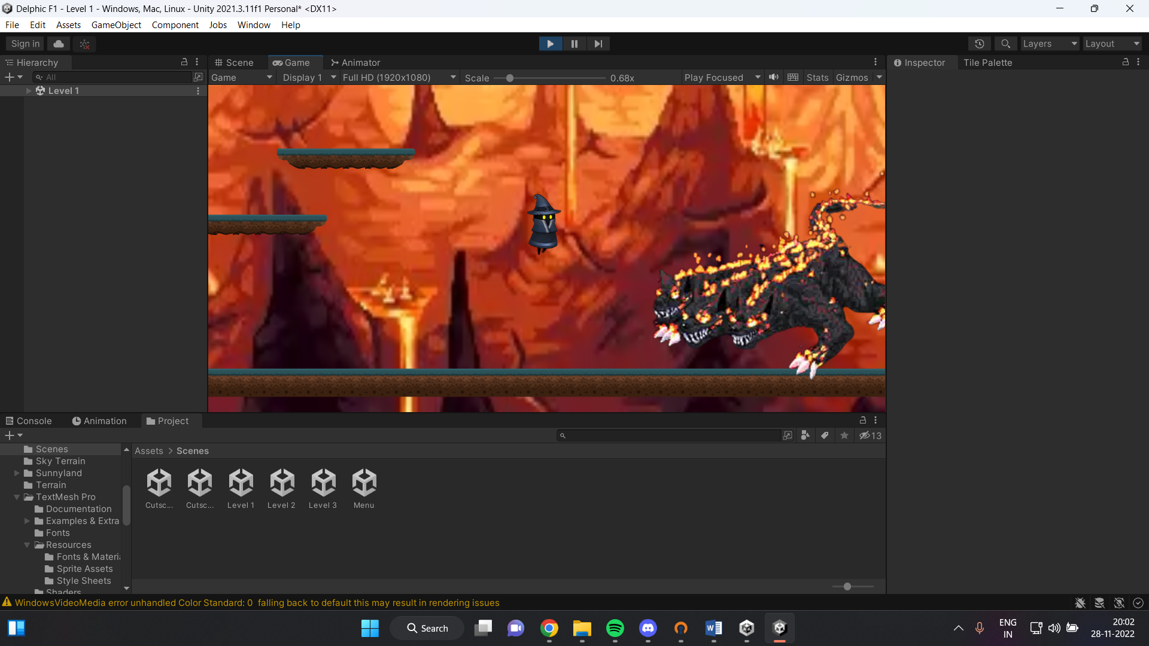

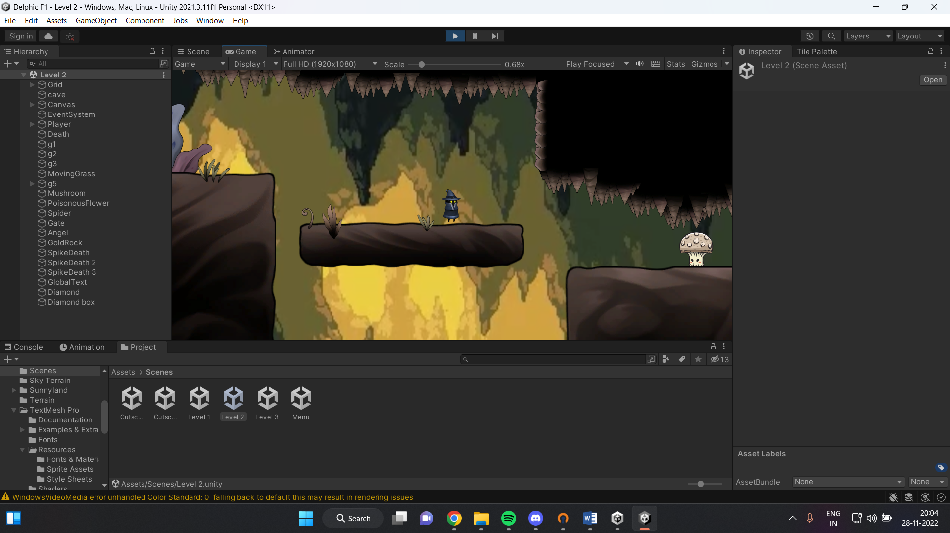

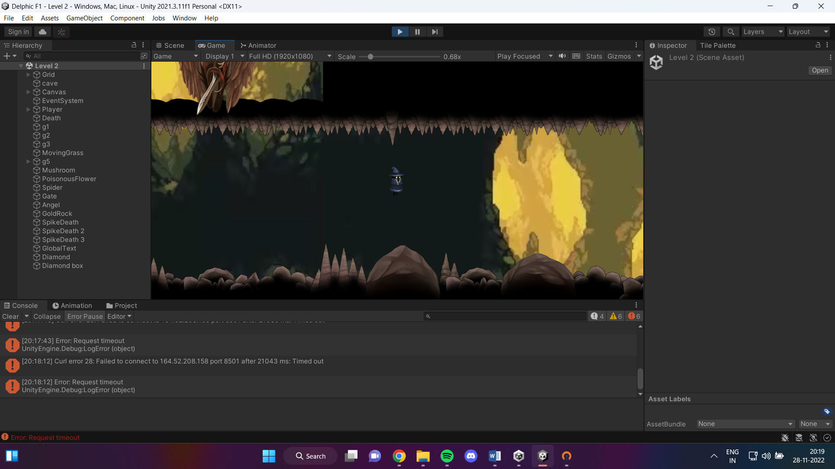

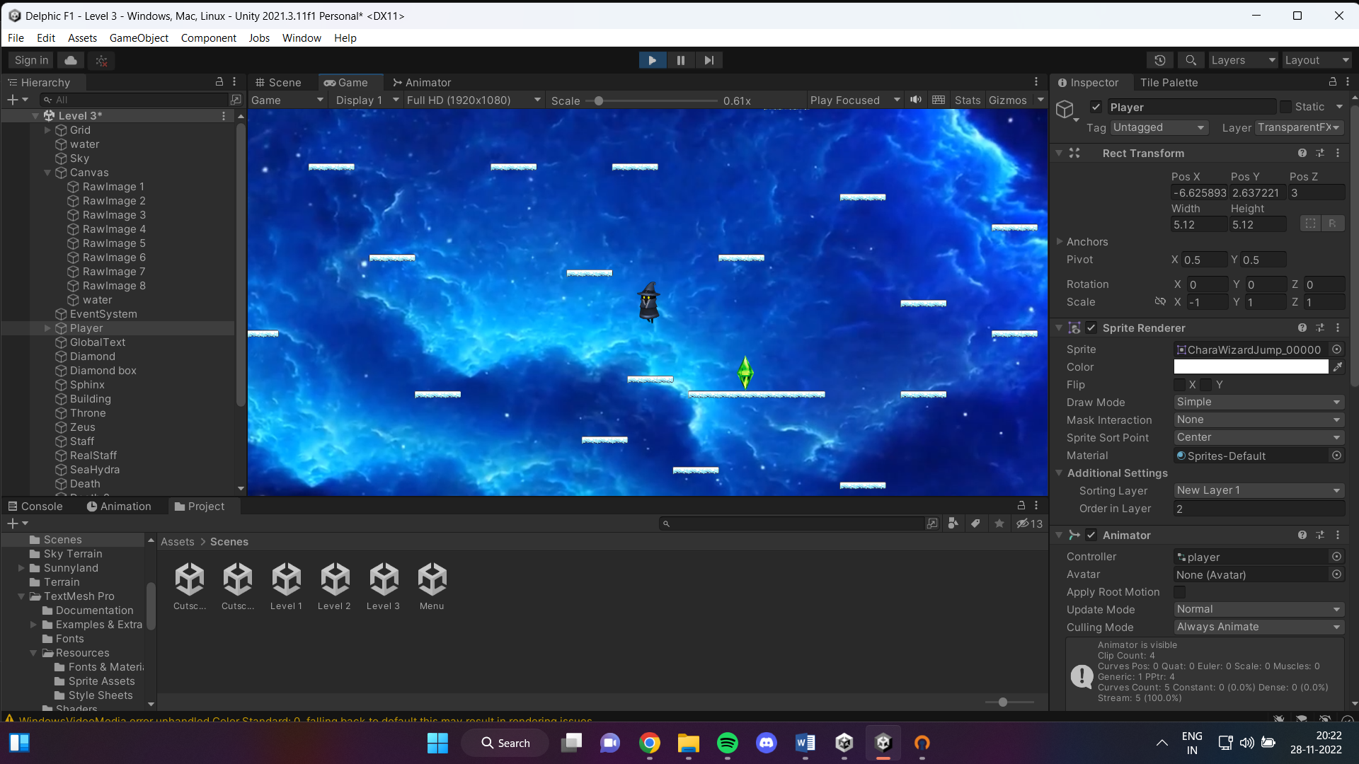

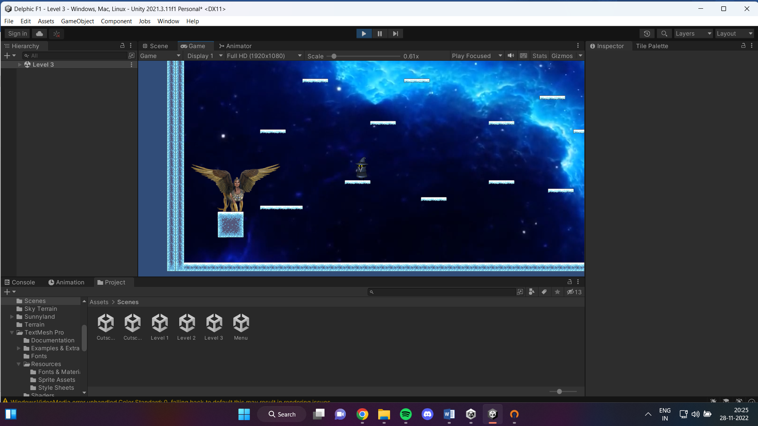

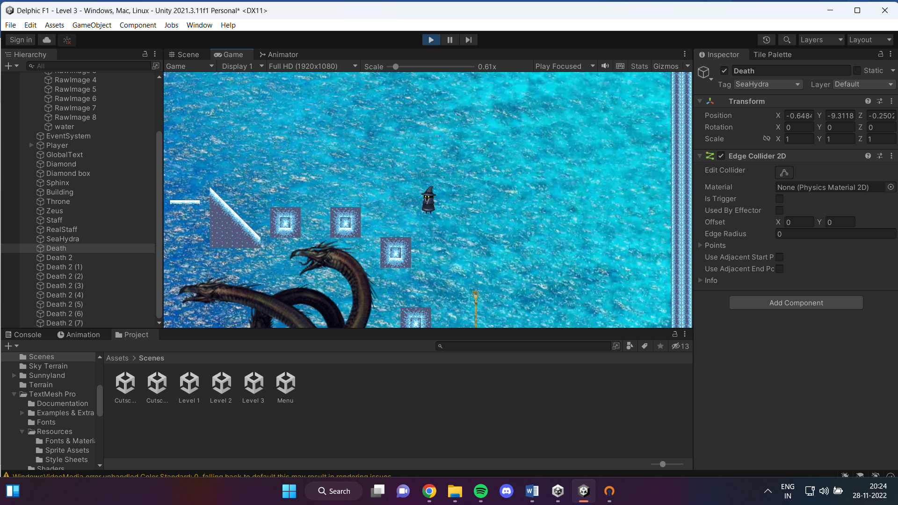

Differences

The current game made had the sublevels combined as was mentioned in the GDD. The health points for the player were not added but instead, the levels were used as checkpoints where if the player dies, it would have to restart from the same level it died instead of from the start. Sounds were added at the death of the player as well as the completion of the level however there was no music playing throughout the game due to copyright issues :(

The leaderboard with penalties is a work in progress.

Several more objects added than mentioned, animations and unique interactions were made.

Added more ways to die and the beautiful sky maze (slightly hard).

## REVIEWS!

Text, letter

Description generated with very high confidenceText, letter

Description generated with very high confidence